TITLE: STUDENT BOX
Student Management System
PROJECT REPORT
Submitted By:  Group 01  Name  ID: C261002  Name: Raisul Islam Rakib  ID: C261006  Name: Mohammad Ferdous  ID: C261008  Name: Mohammd Numan  ID: C261009  Name: Abrar Ahmed | Submitted To:  Mr. MD Tanvir Ahammed Shawon  Lecturer  Department of Computer Science & Engineering (CSE)  International Islamic University Chittagong (IIUC)
Course: Computer Programming lab 1 , Course Code: CSE-1122
Department: Bsc in Computer Science & Engineering (CSE) Submission Date: 07 / 08 / 2026

Table of Contents
1. Project Name | 4
2. Introduction | 4
3. Motivation | 5
4. Applications | 5
5. Objectives | 6
6. Source Code | 6-28
7. Sample Input and Output | 28-37
8. Conclusion | 37-38
References | 38

1. Project Name
Student Box – Student Management System

2. Introduction
Student Box is a console-based Student Management System developed using the C programming language. The system is designed to simplify the management of student information in an educational institution.
The project allows users to add new student information, display all students, search students by Student ID, update student information, delete student records, calculate student grades based on CGPA, and save all data permanently using file handling.
The application uses important C programming concepts such as structures, arrays, functions, loops, conditional statements, string handling, and file handling. The project is easy to use and provides a simple menu-driven interface.

3. Motivation
Managing student records manually requires a lot of time and may lead to mistakes. The main motivation behind this project is to develop a simple digital system that can organize student information efficiently.
This project also helps students understand practical programming concepts and improves problem-solving skills using the C programming language.

4. Applications
- Add new student information.
- Display all student records.
- Search student information using Student ID.
- Update existing student information.
- Delete student records with confirmation.
- Calculate student grades from CGPA.
- Store student information permanently using text files.
- Reduce manual paperwork.
- Improve accuracy in student record management.

5. Objectives
- To develop a Student Management System using C.
- To learn structure and function implementation.
- To understand file handling techniques.
- To perform CRUD (Create, Read, Update, Delete) operations.
- To calculate student grades automatically.
- To improve programming and logical thinking skills.
- To maintain student information efficiently.

6. Source Code
The project is implemented using the C Programming Language.
Development Environment:
- Programming Language: C
- IDE: Code::Blocks
- Compiler: GCC
Functions Used:
- addStudent()
- displayStudent()
- searchStudent()
- updateStudent()
- deleteStudent()
- calculateGrade()
- saveFile()
- loadFile()
Features Implemented:
- ✔ Add Student Information
- ✔ Display Student List
- ✔ Search Student by ID
- ✔ Update Student Information
- ✔ Delete Student with Confirmation
- ✔ Calculate Student Grade
- ✔ Save Data into File
- ✔ Load Data Automatically When Program Starts

C Program Source Code:
#include<stdio.h>
#include<string.h>
#include<stdlib.h>

typedef struct student
{
char id[20];
char name[50];
char department[30];
char semester[10];
double cgpa;
char grade[5];
} STD;

void saveFile(STD student[],int count);
void loadFile(STD student[],int *count);
int checkDuplicateID(STD student[],int count,char id[]);
void displayHeader();
void showmenu();
void pauseScreen();
void addstudent(STD student[],int *count);
void displaystudent(STD student[],int count);
void searchstudent(STD student[],int count);
void updatestudent(STD student[],int count);
void deletestudent(STD student[],int *count);
void calculateGrade(STD student[],int count);

int main()
{
STD student[100];
int count = 0,choice;

loadFile(student,&count);

while(1)
{
displayHeader();
showmenu();
printf("Enter your choice: ");
scanf("%d",&choice);
switch(choice)
{
case 1:
addstudent(student,&count);
break;
case 2:
displaystudent(student,count);
break;
case 3:
searchstudent(student,count);
break;
case 4:
updatestudent(student,count);
break;
case 5:
deletestudent(student,&count);
break;
case 6:
calculateGrade(student,count);
break;
case 7:
{
char choice;

printf("\nAre you sure you want to exit? (Y/N): ");
scanf(" %c",&choice);

if(choice == 'Y' || choice == 'y')
{
saveFile(student,count);
printf("Data saved successfully. Thank you\n");
exit(0);
}
else if(choice == 'N' || choice == 'n')
{
printf("Exit cancelled.\n");
}

break;
}
default:
printf("Invalid choice! Please select 1-7.\n");
}
pauseScreen();
}
return 0;
}

void displayHeader()
{
printf("\n************************************************\n");
printf(" Student Box\n");
printf("International Islamic University Chittagong\n");
printf("************************************************\n");
}

void showmenu()
{
printf("\n====================================\n");
printf(" Main Menu\n");
printf("======================================\n");
printf("1. Add Student Information\n");
printf("2. Display Student Information\n");
printf("3. Search Student Information\n");
printf("4. Update Student Information\n");
printf("5. Delete Student Information\n");
printf("6. Calculate Student Grade\n");
printf("7. Save & Exit\n");
printf("======================================\n");
}

void addstudent(STD student[],int *count)
{
if(*count >= 100)
{
printf("Student limit reached! Cannot add more.\n");
return;
}

printf("\n--- Add Student Information ---\n");

int duplicate;

do
{
printf("Enter ID: ");
scanf("%s",student[*count].id);

duplicate = checkDuplicateID(student,*count,student[*count].id);

if(duplicate == 1)
{
printf("ID already exits! Please enter another ID.\n");
}
}
while(duplicate == 1);

printf("Enter Name: ");
scanf(" %[^\n]",student[*count].name);

printf("Enter Department: ");
scanf(" %[^\n]",student[*count].department);

int sem;

do
{
printf("Enter Semester (1-12): ");
scanf("%s",student[*count].semester);

sem = atoi(student[*count].semester);

if(sem < 1 || sem > 12)
{
printf("Invalid Semester! Please enter a value between 1 and 12.\n");
}
}
while (sem < 1 || sem > 12);

do
{
printf("Enter CGPA (0.0 - 4.0): ");
scanf("%lf",&student[*count].cgpa);

if(student[*count].cgpa < 0 || student[*count].cgpa > 4)
{
printf("Invalid CGPA! Please enter a value between 0.0 and 4.0.\n");
}
}
while (student[*count].cgpa < 0 || student[*count].cgpa > 4);

strcpy(student[*count].grade,"N/A");

(*count)++;

printf("Student information added successfully!\n");
}

void displaystudent(STD student[],int count)
{
if(count == 0)
{
printf("No student information available.\n");
return;
}

printf("\n%-12s %-30s %-15s %-10s %-5s\n","ID","Name","Department","Semester","CGPA");
printf("------------------------------------------------------------------------------\n");

for(int i = 0; i < count; i++)
{
printf("%-12s %-30s %-15s %-10s %-5.2lf\n",student[i].id,student[i].name,student[i].department,student[i].semester,student[i].cgpa);
}
}

void searchstudent(STD student[],int count)
{
if(count == 0)
{
printf("No student information available.\n");
return;
}

char searchid[20];
printf("Enter Student ID to search: ");
scanf("%s",searchid);

int found = 0;

for(int i = 0; i < count; i++)
{
if(strcmp(student[i].id,searchid) == 0)
{
printf("\n--- Student Information Found ---\n");
printf("ID: %s\n",student[i].id);
printf("Name: %s\n",student[i].name);
printf("Department: %s\n",student[i].department);
printf("Semester: %s\n",student[i].semester);
printf("CGPA: %.2lf\n",student[i].cgpa);
found = 1;
break;
}
}

if(found == 0)
{
printf("Student with ID %s not found.\n",searchid);
}
}

void updatestudent(STD student[],int count)
{
if(count == 0)
{
printf("No student information available.\n");
return;
}

char updateid[20];
printf("Enter Student ID to update: ");
scanf("%s",updateid);

int found = 0;

for(int i = 0; i < count; i++)
{
if(strcmp(student[i].id,updateid) == 0)
{
printf("\n--- Update Student Information ---\n");

printf("New Name: ");
scanf(" %[^\n]",student[i].name);

printf("New Department: ");
scanf(" %[^\n]",student[i].department);

int sem;
do
{
printf("New Semester (1-12): ");
scanf("%s",student[i].semester);

sem = atoi(student[i].semester);

if(sem < 1 || sem > 12)
{
printf("Invalid Semester! Please enter a value between 1 and 12.\n");
}

}
while(sem < 1 || sem > 12);

do
{
printf("New CGPA (0.0 - 4): ");
scanf("%lf",&student[i].cgpa);

if(student[i].cgpa < 0 || student[i].cgpa > 4)
{
printf("Invalid CGPA! Please enter a value between 0.0 and 4.\n");
}
}
while(student[i].cgpa < 0 || student[i].cgpa > 4);

found = 1;
printf("Student information updated succcessfully!\n");
break;
}
}

if(found == 0)
{
printf("Student with ID %s not found.\n",updateid);
}
}

void deletestudent(STD student[],int *count)
{
if(*count == 0)
{
printf("No student information available.\n");
return;
}

char deleteid[20];
printf("Enter Student ID to delete: ");
scanf("%s",deleteid);

int found = 0;

for(int i = 0; i < *count; i++)
{
if(strcmp(student[i].id,deleteid) == 0)
{
found = 1;

printf("\n--- Student Information Found ---\n");
printf("ID: %s\n",student[i].id);
printf("Name: %s\n",student[i].name);
printf("Department: %s\n",student[i].department);
printf("Semester: %s\n",student[i].semester);
printf("CGPA: %.2lf\n",student[i].cgpa);

int choice;

printf("Are you sure you want to delete this student information?\n");
printf("1. Yes\n");
printf("2. No\n");
printf("Enter your choice: ");
scanf("%d",&choice);

if(choice == 1)
{
for(int j = i; j < *count - 1; j++)
{
student[j] = student[j + 1];
}

(*count)--;

printf("Student information deleted successfully!\n");
}
else if(choice == 2)
{
printf("Deletion canceled.\n");
}
else
{
printf("Invalid choice! Deletion canceled.\n");
}

break;
}
}

if(found == 0)
{
printf("Student with ID %s not found.\n",deleteid);
}
}

void calculateGrade(STD student[],int count)
{
if(count == 0)
{
printf("No student information available.\n");
return;
}

char searchid[20];
printf("\nEnter Student ID to see result: ");
scanf("%s",searchid);

int found = 0;

for(int i = 0; i < count; i++)
{
if(strcmp(student[i].id,searchid) == 0)
{
found = 1;

if(student[i].cgpa >= 3.75)
{
strcpy(student[i].grade,"A+");
}
else if(student[i].cgpa >= 3.50)
{
strcpy(student[i].grade,"A");
}
else if(student[i].cgpa >= 3.25)
{
strcpy(student[i].grade,"B+");
}
else if(student[i].cgpa >= 3.00)
{
strcpy(student[i].grade,"B");
}
else if(student[i].cgpa >= 2.75)
{
strcpy(student[i].grade,"C+");
}
else if(student[i].cgpa >= 2.50)
{
strcpy(student[i].grade,"C");
}
else if(student[i].cgpa >= 2.00)
{
strcpy(student[i].grade,"D");
}
else
{
strcpy(student[i].grade,"F");
}

printf("\n============================================\n");
printf(" Academic Result\n");
printf("============================================\n");

printf("ID: %s\n",student[i].id);
printf("Name: %s\n",student[i].name);
printf("Department: %s\n",student[i].department);
printf("Semester: %s\n",student[i].semester);

printf("--------------------------------------------\n");

printf("CGPA: %.2lf\n",student[i].cgpa);
printf("Grade: %s\n",student[i].grade);

printf("--------------------------------------------\n");

if(strcmp(student[i].grade,"F") == 0)
{
printf("Status: Failed\n");
}
else
{
printf("Status: Passed\n");
}

printf("============================================\n");

break;
}
}

if(found == 0)
{
printf("\nStudent with ID %s not found!\n",searchid);
}
}

void pauseScreen()
{
printf("\nPress Enter to continue...");
getchar();
getchar();
}

int checkDuplicateID(STD student[],int count,char id[])
{
for(int i = 0; i < count; i++)
{
if(strcmp(student[i].id,id) == 0)
{
return 1;
}
}

return 0;
}

void saveFile(STD student[],int count)
{
FILE *fp;

fp = fopen("student.txt","w");

if(fp == NULL)
{
printf("File cannot be opened!\n");
return;
}

for(int i = 0; i < count; i++)
{
fprintf(fp,"%s\n",student[i].id);
fprintf(fp,"%s\n",student[i].name);
fprintf(fp,"%s\n",student[i].department);
fprintf(fp,"%s\n",student[i].semester);
fprintf(fp,"%.2lf\n",student[i].cgpa);
fprintf(fp,"%s\n",student[i].grade);
}

fclose(fp);
}

void loadFile(STD student[],int *count)
{
FILE *fp;

fp = fopen("student.txt","r");

if(fp == NULL)
{
return;
}

while(fscanf(fp,"%s\n",student[*count].id) == 1)
{
if(*count >= 100)
{
break;
}

fgets(student[*count].name,50,fp);
student[*count].name[strcspn(student[*count].name,"\n")] = 0;

fgets(student[*count].department,30,fp);
student[*count].department[strcspn(student[*count].department,"\n")] = 0;

fscanf(fp,"%s\n",student[*count].semester);

fscanf(fp,"%lf\n",&student[*count].cgpa);

fgets(student[*count].grade,20,fp);
student[*count].grade[strcspn(student[*count].grade,"\n")] = 0;

(*count)++;
}

fclose(fp);
}
7. Sample Input and Output
Sample Input:
Student ID : C261006
Name : Mohammad Ferdous
Department : CSE
Semester : 1st
CGPA : 3.80
Sample Output:
Student Added Successfully.
Student List
SL ID Name Department Semester CGPA Grade
1 C261006 Ferdous CSE 1st 3.80 A+
Grade Calculation Reference Table:
CGPA Range | Grade
3.75 – 4.00 | A+
3.50 – 3.74 | A
3.25 – 3.49 | B+
3.00 – 3.24 | B
2.75 – 2.99 | C+
2.50 – 2.74 | C
2.00 – 2.49 | D
Below 2.00 | F

Screenshots:
Screenshot: Main Menu ]
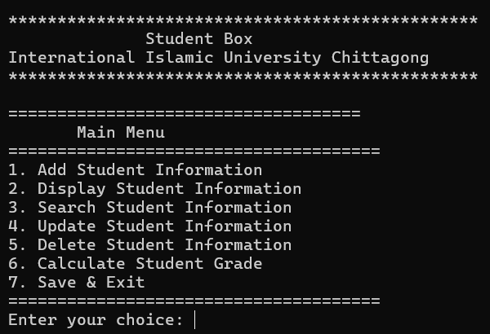

- Screenshot: Add Student
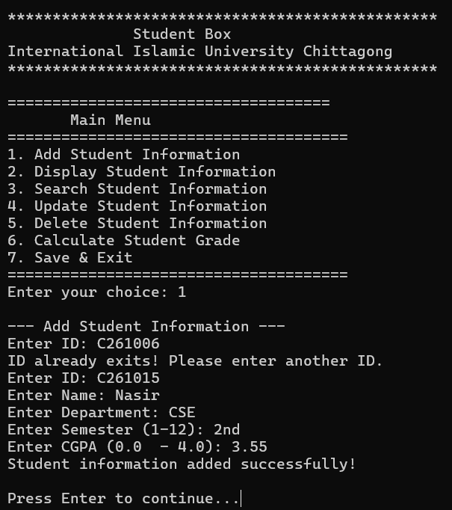

[ Screenshot: Display Student List ]
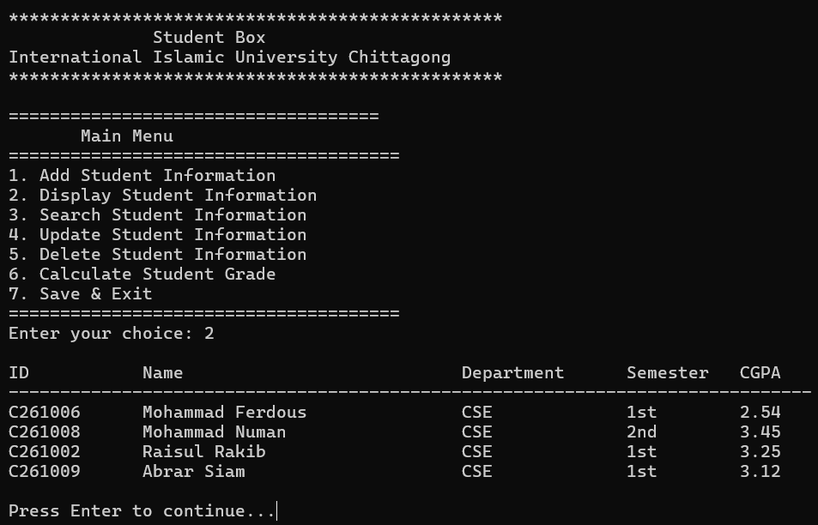

- [ Screenshot: Search Student ]
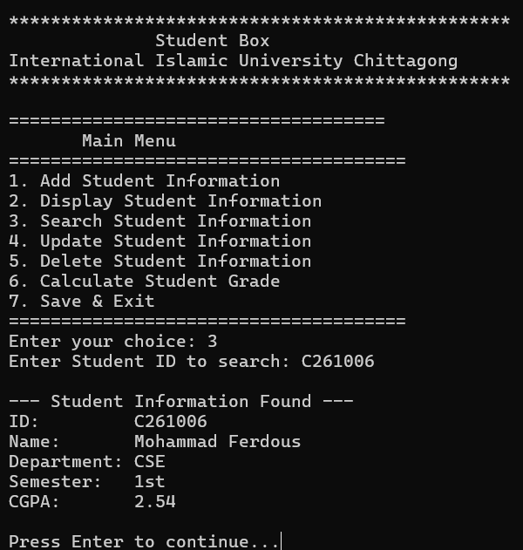

- [ Screenshot: Update Student ]
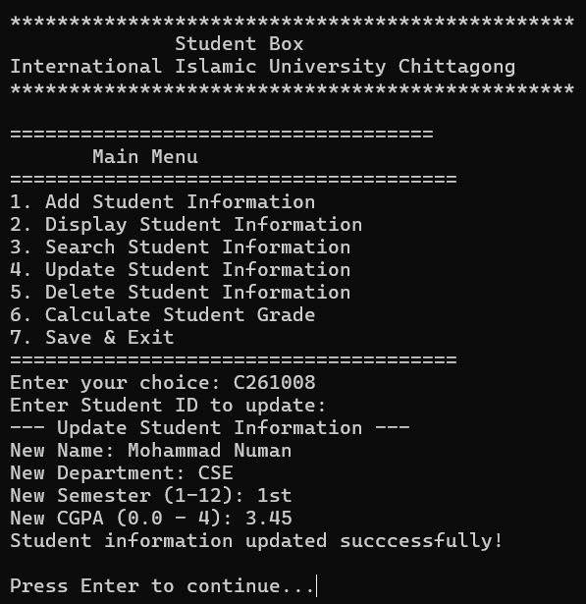

- [ Screenshot: Delete Student ]

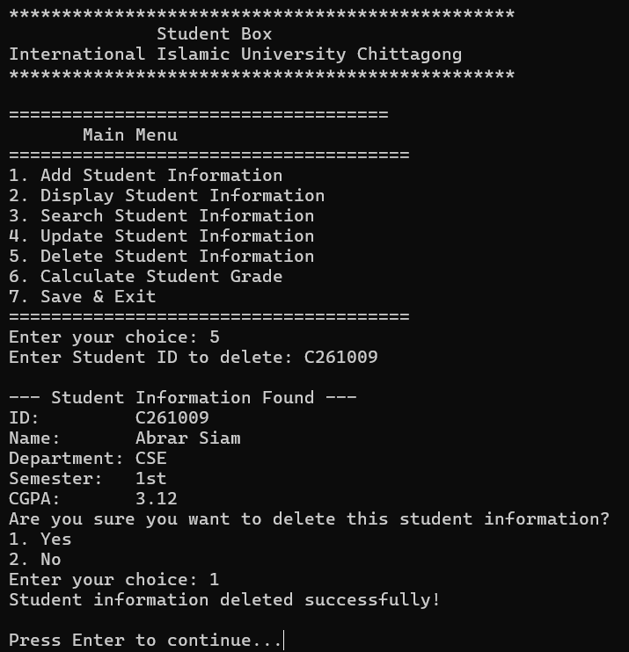

- [ Screenshot: Calculate Grade ]
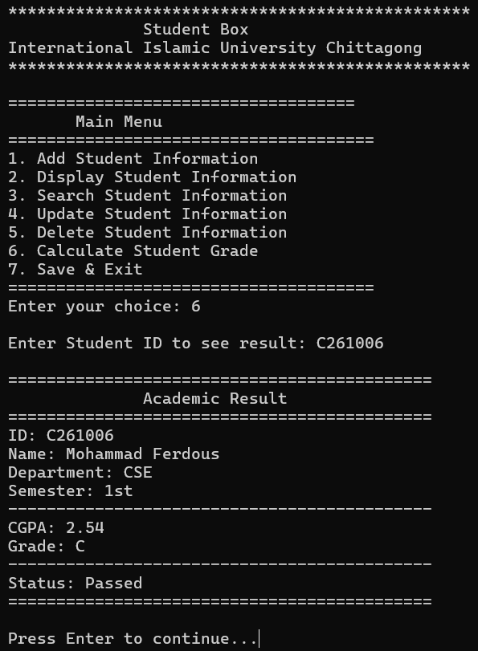

- [ Screenshot: Save and Exit ]
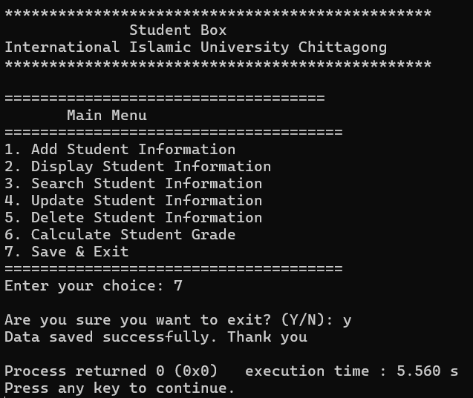

8. Conclusion
The Student Box project successfully fulfills the requirements of a basic Student Management System. It provides a simple, efficient, and user-friendly way to manage student records.
Through this project, we learned how to use structures, arrays, functions, loops, file handling, and string manipulation in C programming. We also gained practical experience in designing a menu-driven application and solving real-world problems using programming.
The system stores student information permanently, making it more useful than a temporary program. This project has improved our programming knowledge and teamwork skills and will be helpful for future software development projects.
References
- C Programming Language by Brian W. Kernighan & Dennis M. Ritchie
- Code::Blocks IDE Documentation
- Class Lecture Notes
- Structured Programming Course Materials

